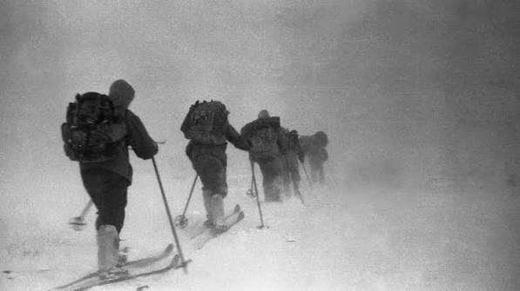
By Swetha on July 14 at 12:19 am IST
"Nine experienced hikers. One freezing mountain. A mystery that remains unsolved to this day."
INTRODUCTION
The Dyatlov Pass Incident is one of the most chilling unsolved mysteries in modern history. In February 1959, nine experienced hikers disappeared during a routine expedition in the Rural Mountains of Russia. What happened next was so bizarre and terrifying that even after more than six decades, no one knows the full truth.

THE EXPEDITION
The group was led by 23-year-old Igor Dyatlov, an engineering student, along with nine other hikers. They were all experienced, fit, and well-prepared for the challenging winter trek.
Their goal was to reach Mount Otorten, one of the most remote peaks in the northern Ural Mountains. However, one member, Yuri Yudin, returned home early due to illness, making him the expedition's only survivor. When the group failed to return as scheduled, rescue teams were sent to search for them.

THE NINE HIKERS
THE DYATLOV PASS INCIDENT:
THE MYSTERY THAT STILL HAUNTS
THE WORLD

A TERRIFYING DISCOVERY
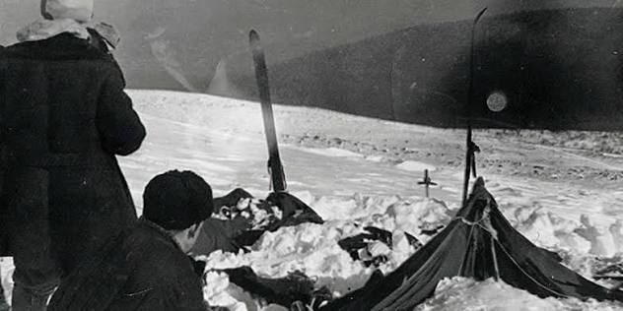
Rescuers eventually found the hikers' tent on the slopes of Kholat Syakhl, a mountain whose name is often translated as "Mountain of the Dead."
The tent had been cut open from the inside, suggesting the hikers fled in panic instead of using the entrance. Inside, rescuers found food, warm clothing, boots, cameras, and other belongings left behind.
Footprints led away from the campsite, many made by hikers wearing only socks or no shoes at all despite temperatures reaching nearly -30°C.
Surviving in such conditions without proper clothing is almost impossible.

THE BODIES
The first victims were discovered beneath a cedar tree, where they had attempted to build a fire. Other bodies were found scattered across the mountainside, some appearing to crawl back toward the tent before collapsing.
The final four hikers were discovered months later after the snow melted.

Investigators found several disturbing injuries:
- One hiker had a fractured skull.
- Two suffered severe chest injuries comparable to those caused by a high-speed car crash but with almost no external wounds.
- Lyudmila Dubinina was missing her tongue, eyes, and parts of her facial tissue.
- Traces of radioactive contamination were detected on some of the hikers' clothing.
These discoveries only deepened the mystery.

THE INVESTIGATION
The Soviet investigation concluded that the hikers died due to "a compelling natural force." No further explanation was provided.
Many documents remained classified for years, and several details surrounding the investigation were never fully explained, fueling decades of speculation.

THEORIES BEHIND THE INCIDENT

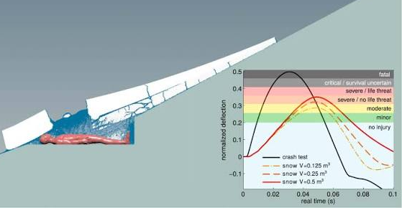
1. Avalanche
The most widely accepted theory suggests a slab avalanche threatened the campsite, forcing the hikers to cut open their tent and flee immediately.
Although modern research supports this possibility, many people question the theory because the tent remained standing and there was little evidence of a major avalanche.

2. Secret Military Testing
Some believe the hikers unknowingly entered a secret Soviet military testing area.
Reports of strange orange lights in the sky and traces of radiation on clothing have led to speculation that experimental weapons or explosions may have been involved.
However, no conclusive evidence has ever confirmed this theory.

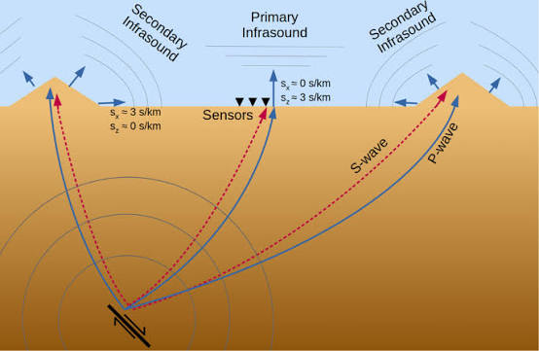
3. Infrasound
Another scientific explanation involves infrasound low-frequency sound waves created by powerful winds.
Researchers suggest these sounds could have caused fear, panic, and disorientation, prompting the hikers to flee. While possible, this theory does not explain the severe injuries suffered by several victims.

4. Paranormal Explanations
Because of the unusual evidence, paranormal theories continue to fascinate people around the world. Some believe the hikers encountered Yeti and UFOs to Spirits or ghosts and Ancient mountain curses but despite their popularity, there is no scientific evidence supporting these claims.

5. Something Unknown
Many researchers believe the complete truth has yet to be discovered.
The strange injuries, missing body parts, radioactive clothing, and the hikers' behavior continue to raise questions that no single theory can fully answer.
More than 65 years later, the mountain continues to guard its secrets.

WHY THE MYSTERY ENDURES
In 2019, Russian authorities reopened the investigation and concluded that a snow slab avalanche, combined with freezing temperatures and poor visibility, was the most likely cause of the tragedy.
Even so, many investigators remain unconvinced.
The unusual injuries, radioactive traces, missing tongue, and unexplained decisions made by the hikers continue to puzzle historians, scientists, and mystery enthusiasts alike.
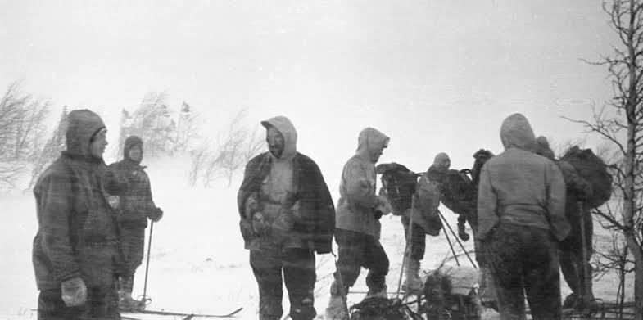

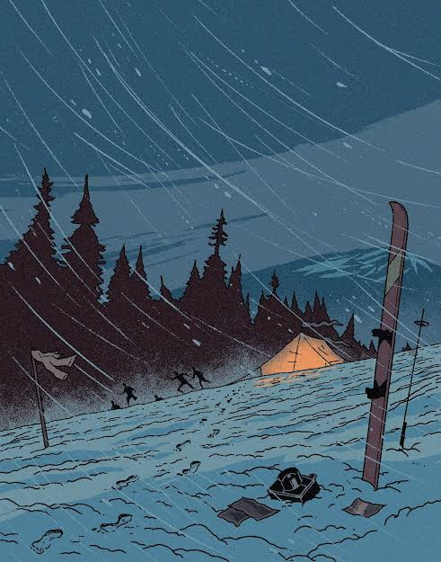
Did You Know?
Although many people refer to the site as Dyatlov Pass, the mountain itself is actually called Kholat Syakhl, a Mansi name commonly translated as "Mountain of the Dead."

CONCLUSION
The Dyatlov Pass Incident remains one of history's greatest unsolved mysteries.
Whether the hikers were victims of an avalanche, a secret military experiment, or something we still cannot explain, one fact remains certain:
Some mysteries are never meant to be solved and perhaps that's what makes the Dyatlov Pass Incident so haunting.

